**Assignment – 1**

* Install Power BI Desktop and share the final screenshot of the report view page which appears when power desktop starts.

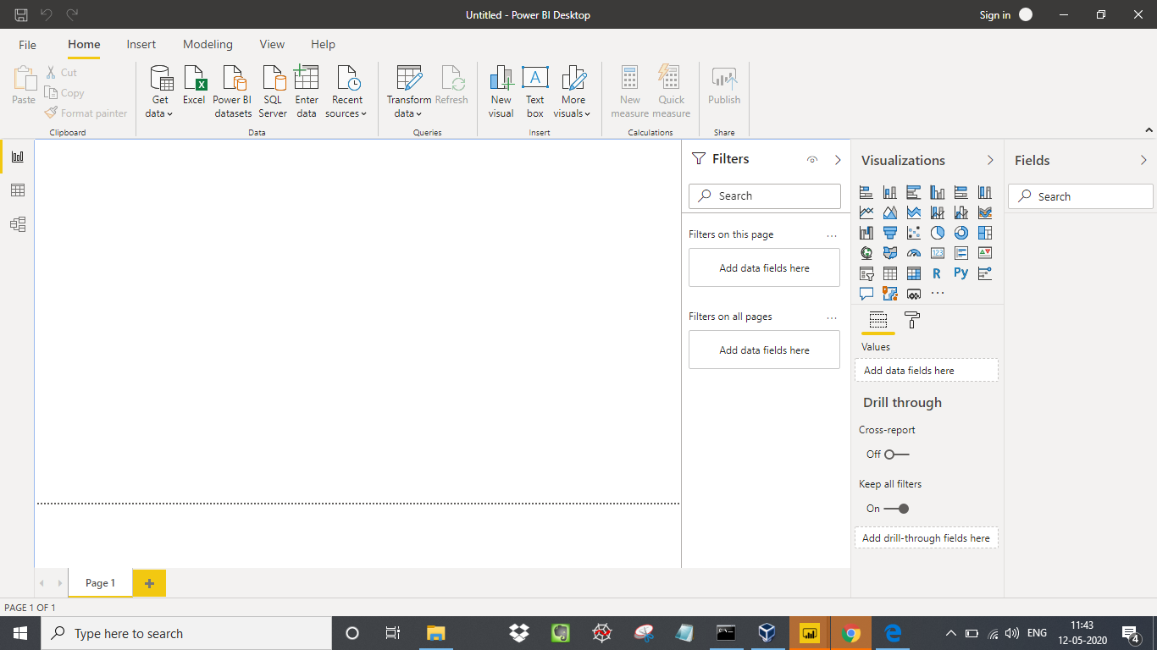

* Prepare a document and with the following screenshot

**− Report View**

Power BI Desktop includes a Report view, where you can create any number of report pages with visualizations. You can move visualizations around, copy and paste, merge, and so on. To change the type of visualization, you can select it on the canvas, then select a new type in **Visualizations**. You can easily take a visual from one Power BI Desktop report and paste it into another report.

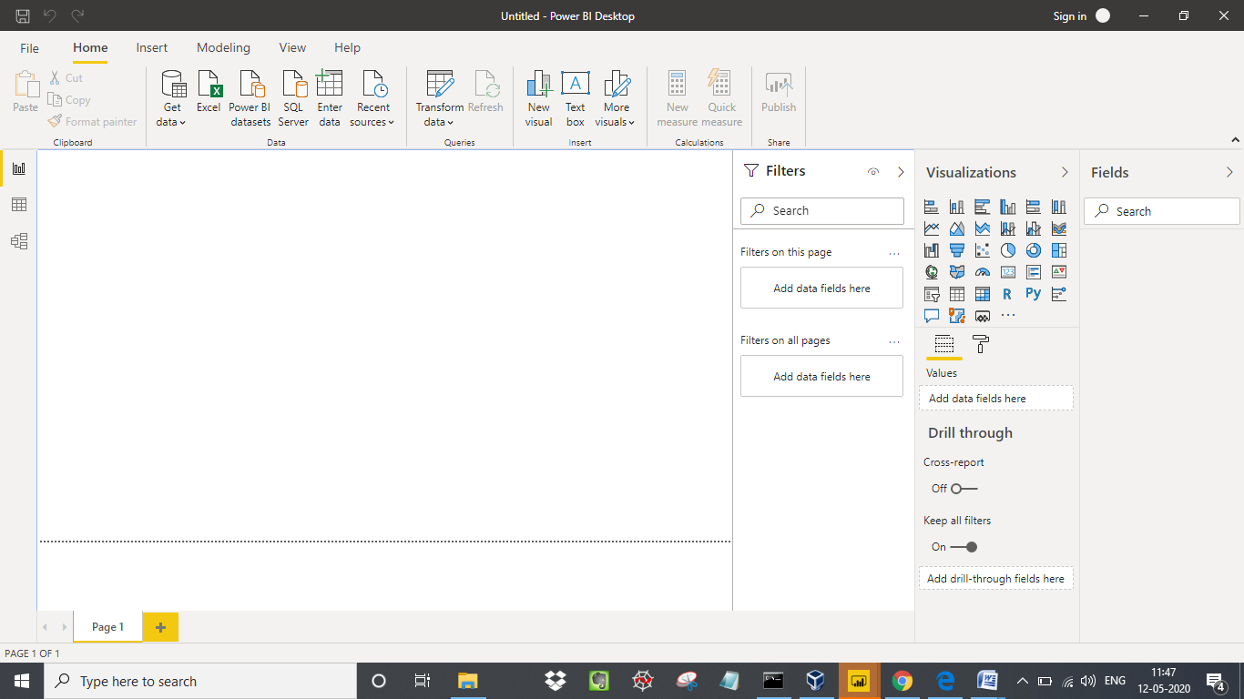

**− Data View**

Data view helps you inspect, explore, and understand data in your Power BI Desktop model. It's different from how you view tables, columns, and data in Power Query Editor. With Data view, you're looking at your data after it has been loaded into the model.

When you're modeling your data, sometimes you want to see what's actually in a table or column without creating a visual on the report canvas. You might want to see right down to the row level. This ability is especially useful when you're creating measures and calculated columns, or you need to identify a data type or data category.

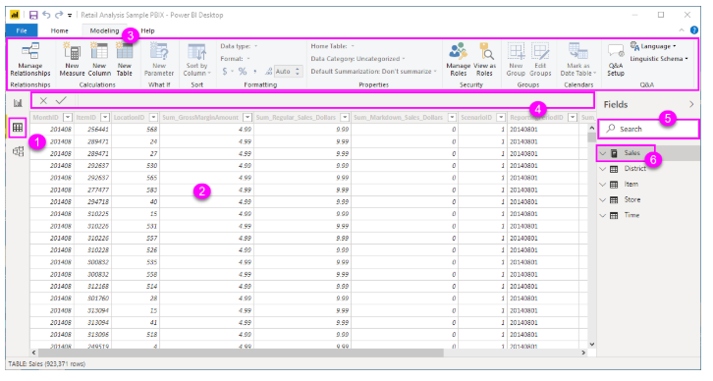

1. **Data view icon**. Select this icon to enter Data view.
2. **Data Grid**. This area shows the selected table and all columns and rows in it. Columns hidden from Report view are greyed out. You can right-click on a column for options.
3. **Modeling ribbon**. Here you can manage relationships, create calculations, change data type, format, data category for a column.
4. **Formula bar**. Enter Data Analysis Expression (DAX) formulas for Measures and Calculated columns.
5. **Search**. Search for a table or column in your model.
6. **Fields list**. Select a table or column to view in the data grid.

**− Model View**

Model view shows all of the tables, columns, and relationships in your model. This view can be especially helpful when your model has complex relationships between many tables. Select the **Model** icon near the side of the window to see a view of the existing model. Hover your cursor over a relationship line to show the columns that are used.

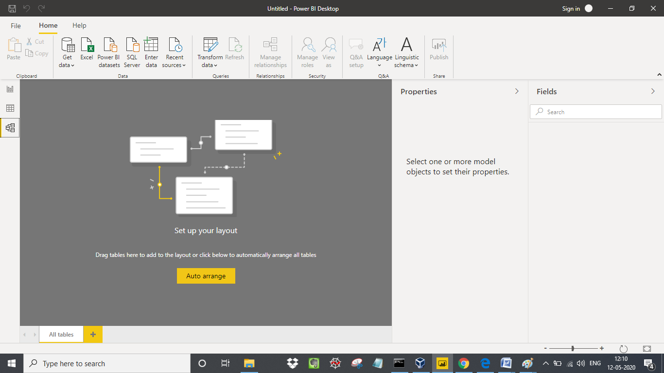

**− Power Query Editor**

With **Power Query** in **Power BI** you can connect to many different data sources, transform the data into the shape you want, and quickly be ready to create reports and insights. When using Power BI Desktop, **Power Query** functionality is provided in the **Power Query Editor**.

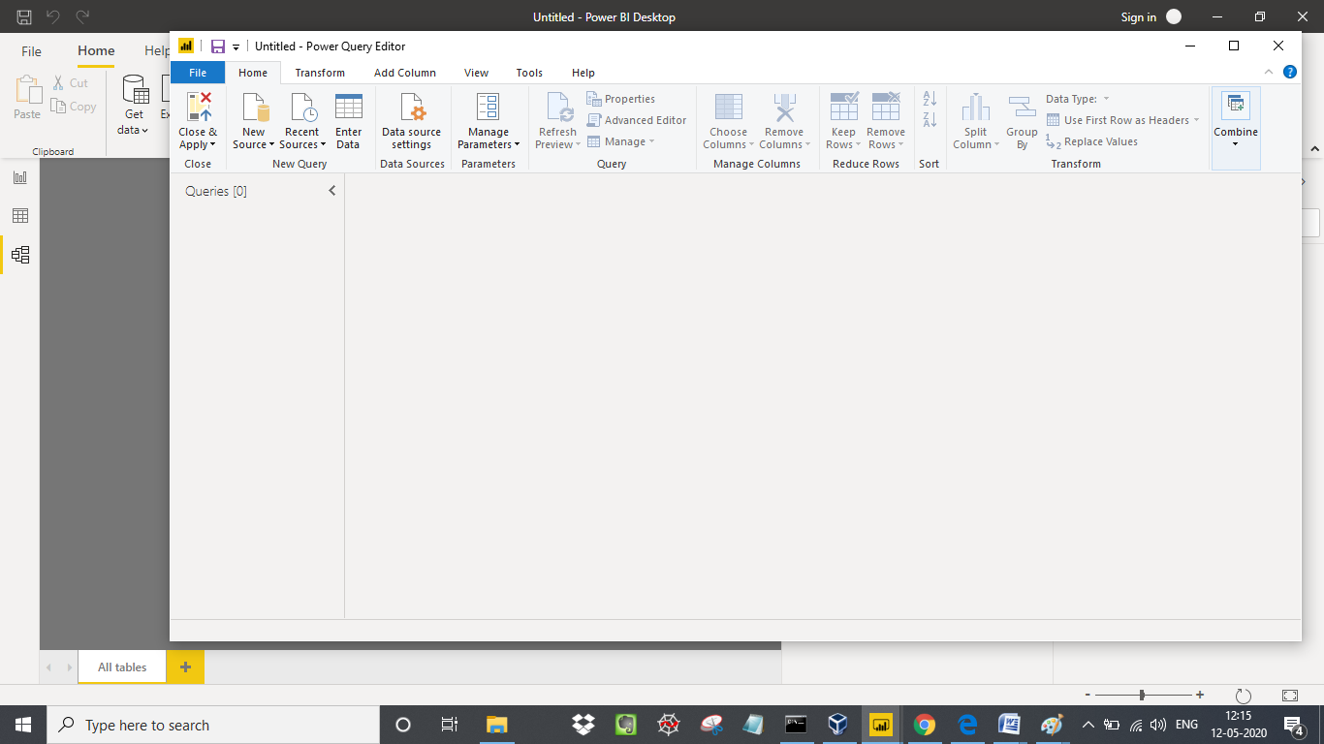

**− Advance Editor**

If you want to see the code that **Power Query Editor** is creating with each step, or want to create your own shaping code, you can use the **Advanced Editor**. To launch the advanced editor, select **View** from the ribbon, then select **Advanced Editor**. A window appears, showing the existing query code.

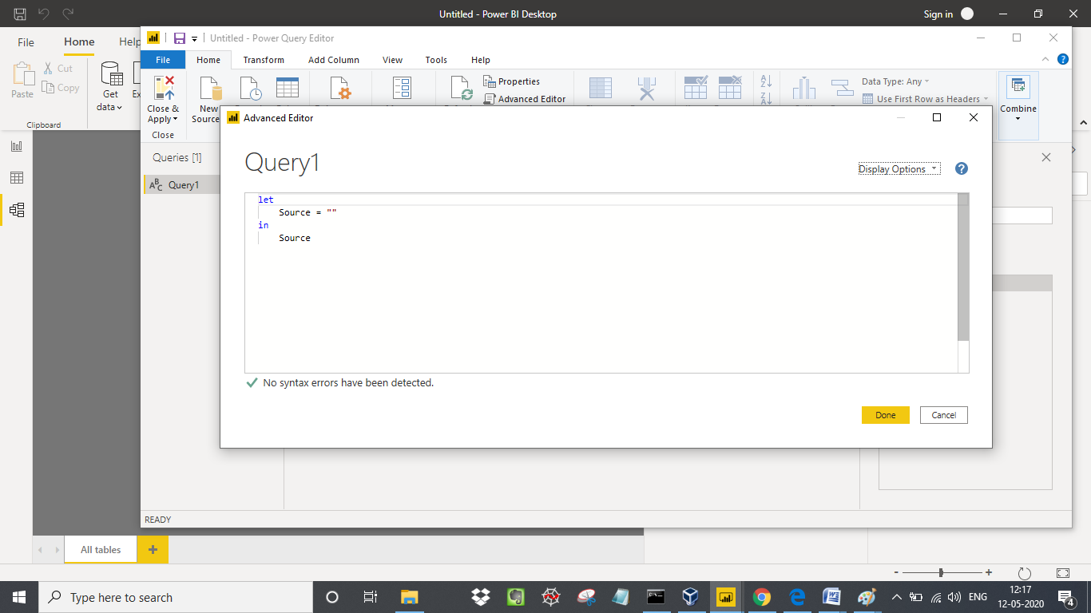

* Prepare a document with details of the following along with their price

− Power BI Desktop

− Power BI Pro

− Power BI Premium

**− Power BI Desktop**

Power BI Desktop is the free version of Power BI that you can install on your local computer as a program, and acts as a companion desktop application to the full version of Power BI. If you need to consolidate your data sources, create your own reports and conduct your own analysis or test it’s capabilities, it’s the perfect version to start with for all skill levels - whether you’re non-IT and want to make your reports more interactive, or analysts seeking richer detail, it's one of the best business analytics tools to use.

Despite its free nature, you may be surprised at what Microsoft has included with Power BI Desktop:

* You can connect and import data from over 70 cloud-based and on-premises sources
* The same rich visualisations and filters from Power BI Pro
* Auto-detect that finds and creates data relationships between tables and formats
* Export your reports to CSV, Microsoft Excel, Microsoft PowerPoint and PDF
* Python support
* Save, upload and publish your reports to the Web and the full Power BI service
* Storage limit of 10 GB per user

Naturally, there are some feature limitations with the free Power BI Desktop that give further incentive to upgrade.

* Can’t share created reports with non-Power BI Pro users
* No App Workspaces
* No API embedding
* No email subscriptions
* No peer-to-peer-sharing
* No support to analyse in Excel within Power BI Desktop
* **Power BI Pro**

Power BI Pro is the full version of Power BI, complete with the ability to use Power BI for both building dashboards and reports and unlimited viewing, sharing and consumption of your created reports (and reports shared by others) - the latter not possible with Power BI Desktop.

A breakdown of Power BI Pro’s differences against Power BI Desktop:

* Ability to embed Power BI visuals into apps (PowerApps, SharePoint, Teams, etc)
* Native integration with other Microsoft solutions (Azure Data Services)
* Share datasets, dashboards and reports with other Power BI Pro users
* Can create App Workspaces and peer-to-peer sharing

Power BI Pro is licensed by individual user. For example, if your organisation has 20 people that need to full capabilities of self-service BI to create dashboards and reports, you need 20 licenses of Power BI Pro, which gives these users full access to creation of reports and unlimited consumption (viewing) of any created content.

If you have a lot of users, Power BI Pro can obviously become quite expensive - but there’s a better option if you have more users that need to consume reports than use Power BI for creating reports, which we detail below.

## Power BI Premium

Power BI Premium differs from the free version and Power BI pro in its licensing model, which only suits a specific size and type of organisation and business scenario. You can purchase Premium in a range of capacity sizes that offer different numbers of memory and virtual cores that can scale as your data analysis requirements change.

With Power BI Premium, you are licensing capacity for your datasets, dashboards and reports, not just licensing all users of that content. In other words, you’re not buying individual licenses, you’re buying them in bulk to allow a large number of your users to use Power BI to view reports. All of your content is stored in Premium and can then be viewed by as many users in your organisation as you want, without additional per-user costs.

**Price comparison**

**Power BI desktop**

Power BI free is for anybody and everybody that wants to glean meaningful insight from their data and apply it to their business. It is ideal for small business owners and individual professionals for whom large scale collaboration and integration is not always necessary.

## Power BI Pro

The Pro plan costs $9.99/user/month. It includes data collaboration, data governance, building dashboards with a 360-degree real-time view and the ability to publish reports anywhere. Users can try it a free trial for 60 days before purchasing the subscription.

## Power BI Premium Cost

The Premium plan starts at $4,995 a month per dedicated cloud compute and storage resource. This does not include the cost of licensing for individual Pro and Free licenses required for each user in your organisation.